1.Introduction
CookBook : Your Virtual Kitchen Assistant

Team ID : NM2025TMID31391
Team Leader : SABIHA HASEENA. B
Team member : RIZWANA BEGUM. A
Team member : JENIFA. H
Team member : JESEEFA .H

2. Project Overview

(Introductory content about CookBook as a culinary exploration platform.)

3. Project Objective

User-Friendly Experience

Comprehensive Recipe Management

Technology Stack

4. Pre-Requisites

(Detailed setup requirements: Node.js, npm, React.js, Git, IDE, etc.)

5. Setup Instructions

(DOCX content: SmartInternz portal → extract → open in VS Code → run npm install & npm start.)

6. Project Structure

CookBook/
│-- node_modules/ # Project dependencies
│-- public/ # Public assets (favicon, index.html, etc.)
│-- src/ # Main source folder
│ │-- components/ # Reusable UI components
│ │ │-- About.jsx
│ │ │-- CategoriesHome.jsx
│ │ │-- Footer.jsx
│ │ │-- Hero.jsx
│ │ │-- Navbar.jsx
│ │ │-- NewsLetter.jsx
│ │
│ │-- pages/ # Page-level components (route-based)
│ │ │-- Category.jsx
│ │ │-- Home.jsx
│ │ │-- Recipie.jsx
│ │
│ │-- styles/ # CSS styling files
│ │ │-- About.css
│ │ │-- CategoriesHome.css
│ │ │-- CategoryPage.css
│ │ │-- Footer.css
│ │ │-- Hero.css
│ │ │-- Home.css
│ │ │-- Navbar.css
│ │ │-- NewsLetter.css
│ │ │-- Recipie.css
│ │
│ │-- images/ # Project images (assets for UI)
│ │
│ │-- App.css # Global styles for App component
│ │-- App.js # Root component
│ │-- App.test.js # Unit testing file for App
│ │-- index.css # Global CSS
│ │-- index.js # Entry point of React app
│ │-- logo.svg # Project logo asset
│ │-- reportWebVitals.js # Performance measuring
│ │-- setupTests.js # Testing configuration
│
│-- .gitignore # Git ignore rules
│-- package-lock.json # Locked dependency versions
│-- package.json # Project dependencies & scripts
│-- README.md # Project documentation

7. Project Flow

Project Demo: View demo

Source Code: Access code folder

8. Project Setup and Configuration

Required tools: React.js, React Router DOM, React Icons, Bootstrap/Tailwind CSS, Axios

References: React, Bootstrap, Axios, React Router documentation links

9. Project Development

Setup routing paths for navigation

Develop Navbar & Hero components

Build popular categories & fetch from TheMealDB API

Add trending dishes on homepage

Create category page for dishes

Build recipe page with ingredients, instructions & demo video

Important Code Snippets:

Fetching categories (useState + useEffect + axios)

Fetching food items under a category

Fetching recipe details by recipe ID

11. Project Folder Screenshot

The CookBook project is organized into multiple directories and files for better maintainability:
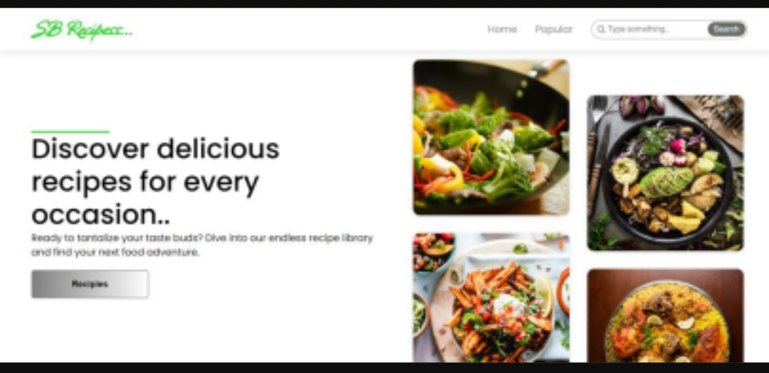

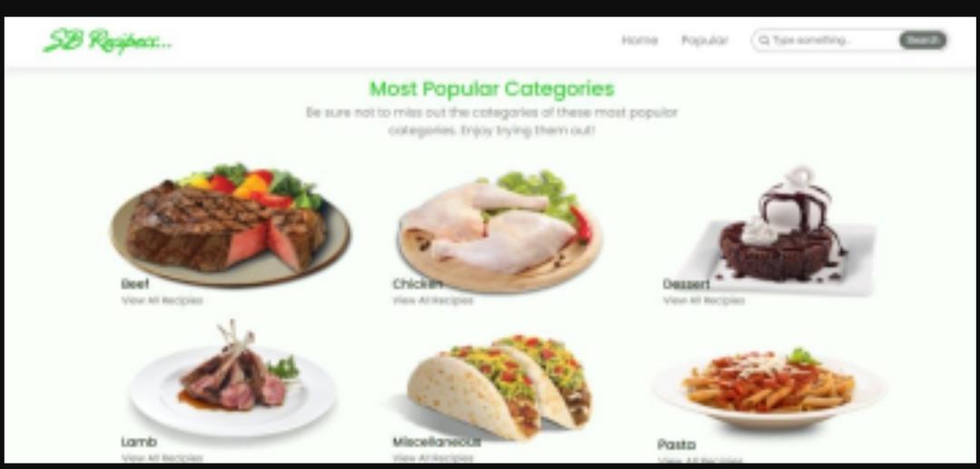
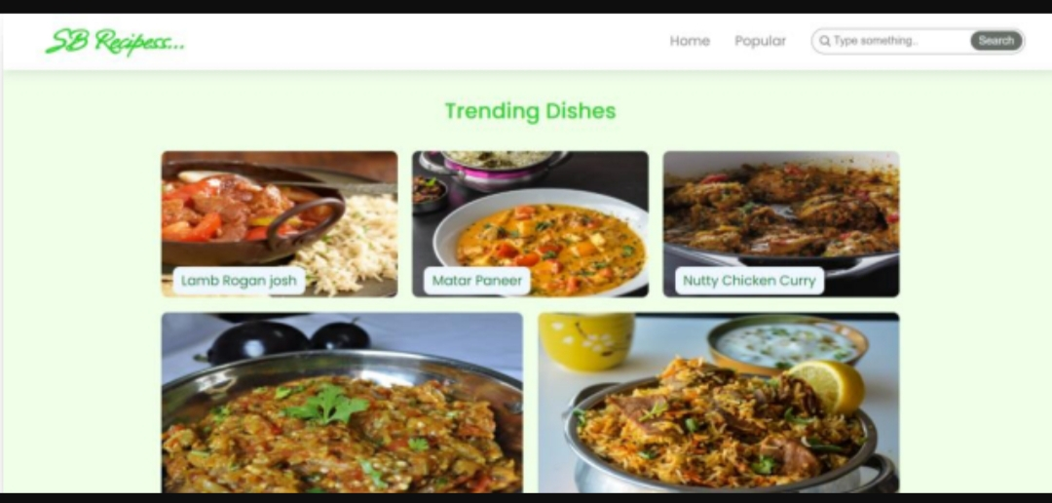

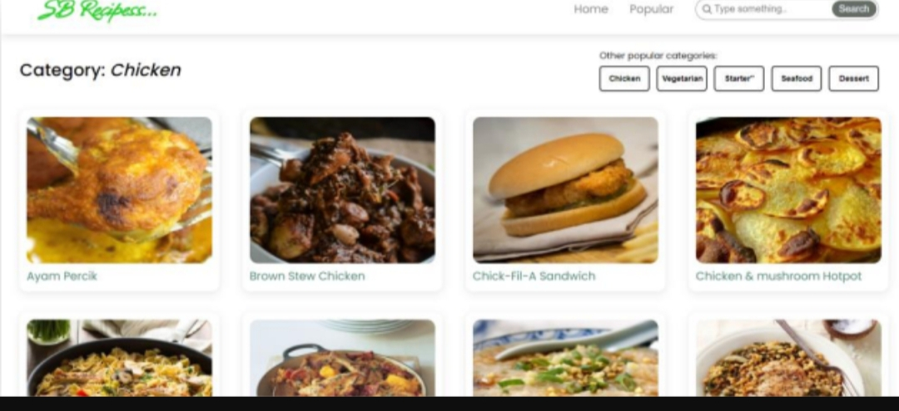
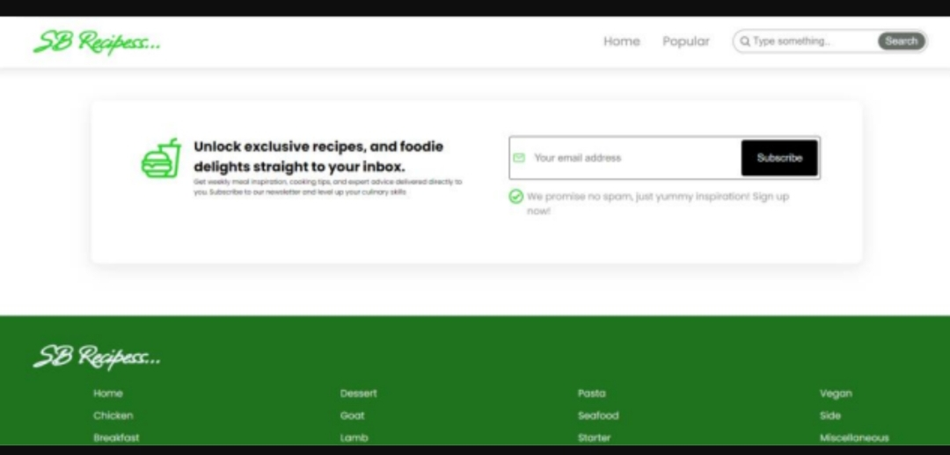

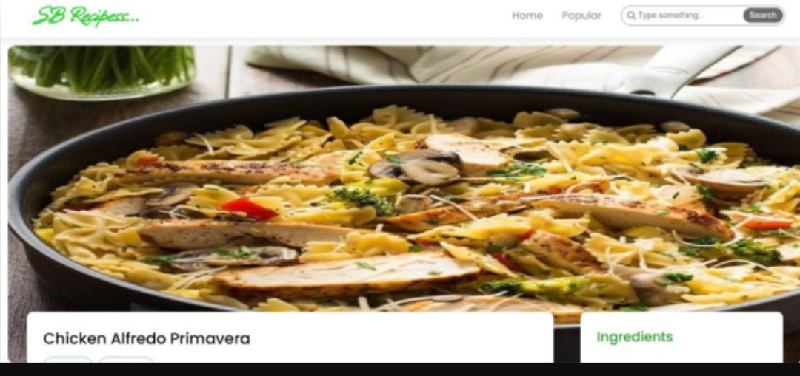

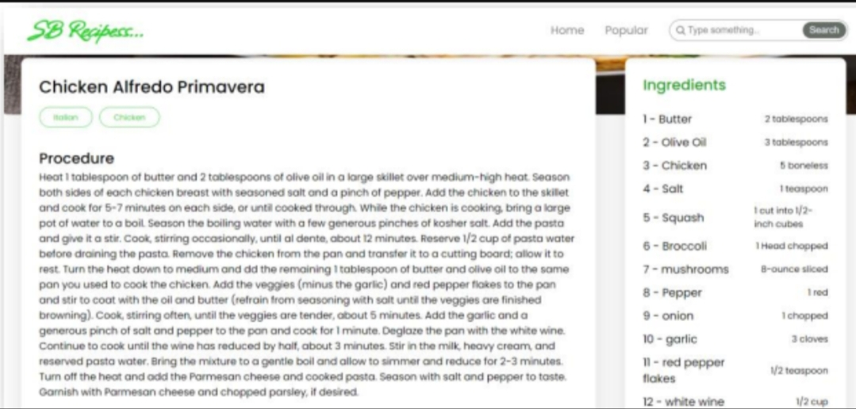
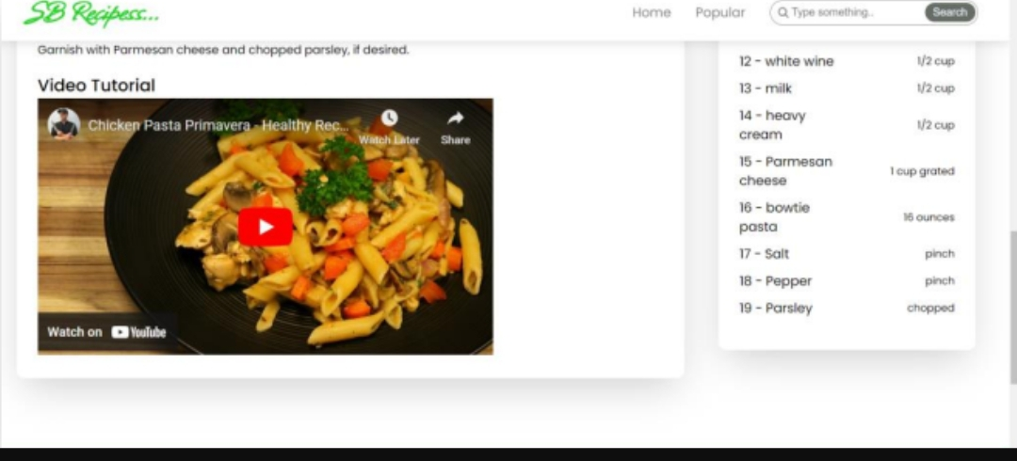

12.Future Enhancements
User Authentication: Implement secure login & signup using JWT or Firebase Authentication.

User Profiles: Allow users to create profiles, save favorite recipes, and track cooking history.

Recipe Uploads: Enable users to upload and share their own recipes with the community.

Advanced Search & Filters: Add filtering by ingredients, cuisine, or preparation time.

Mobile Responsiveness: Optimize UI for all devices with a mobile-first design.

AI-Powered Suggestions: Integrate AI to recommend recipes based on user preferences.

Integration with Shopping Lists: Auto-generate shopping lists from selected recipes.

13. Known Issues

API Dependency: Some features depend on external APIs (TheMealDB, Rapid API). If APIs are down, features may not work.

Recipe Data Consistency: Occasionally, recipes fetched may have incomplete or missing information.

Limited Error Handling: Current error handling is basic (console logs) and needs improvement.

UI Glitches: Some CSS styles may not render consistently across all browsers.

Performance Lag: Large API responses may cause slower load times on low-end devices.

Spelling Issue: “Recipie” component/page name should be corrected to “Recipe” for consistency.

